Software engineering Individual Project
Name : Kartikeya Sharma
ApplicationId : 25201462
Abstract
This project presents the design and development of a chess game application built using Java 17 following the Model-View-Controller (MVC) architecture. The system applies core Object-Oriented Programming (OOP) principles such as encapsulation, inheritance, and polymorphism to ensure modularity and scalability. A validation layer has been implemented to manage legal moves, check conditions, and king safety. Advanced chess features like pawn promotion, en passant, and castling are fully supported to provide a realistic gameplay experience. The application uses JUnit for unit testing to ensure code reliability and correctness, and Maven for project management and dependency handling. Overall, this project demonstrates how OOP and MVC design patterns can be effectively applied to build a robust and maintainable chess application.
Introduction
Chess is a classic board game that has been played for centuries. It is a game of strategy between two players who move pieces on a board with 64 squares. Each player starts with 16 pieces, including a king, queen, rooks, bishops, knights, and pawns. The main goal of the game is to checkmate the opponent’s king, which means the king is trapped and cannot escape.
Chess is not only fun but also helps improve thinking, memory, and problem-solving skills. Today, it is played all over the world, both in person and online, by people of all ages.

System Design and Architecture
FLOW
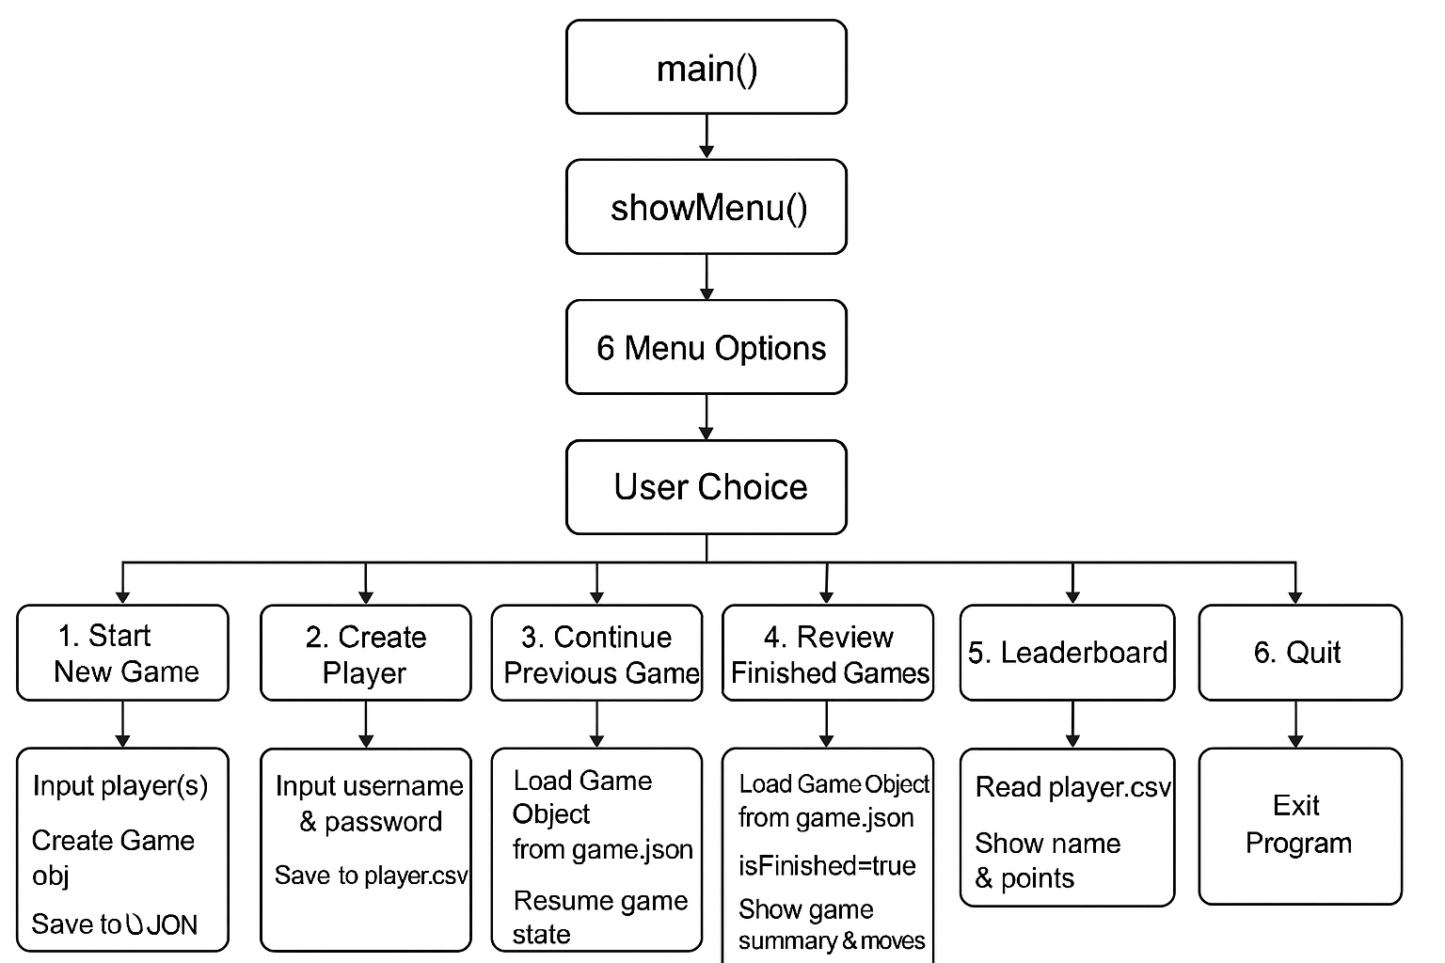
UML
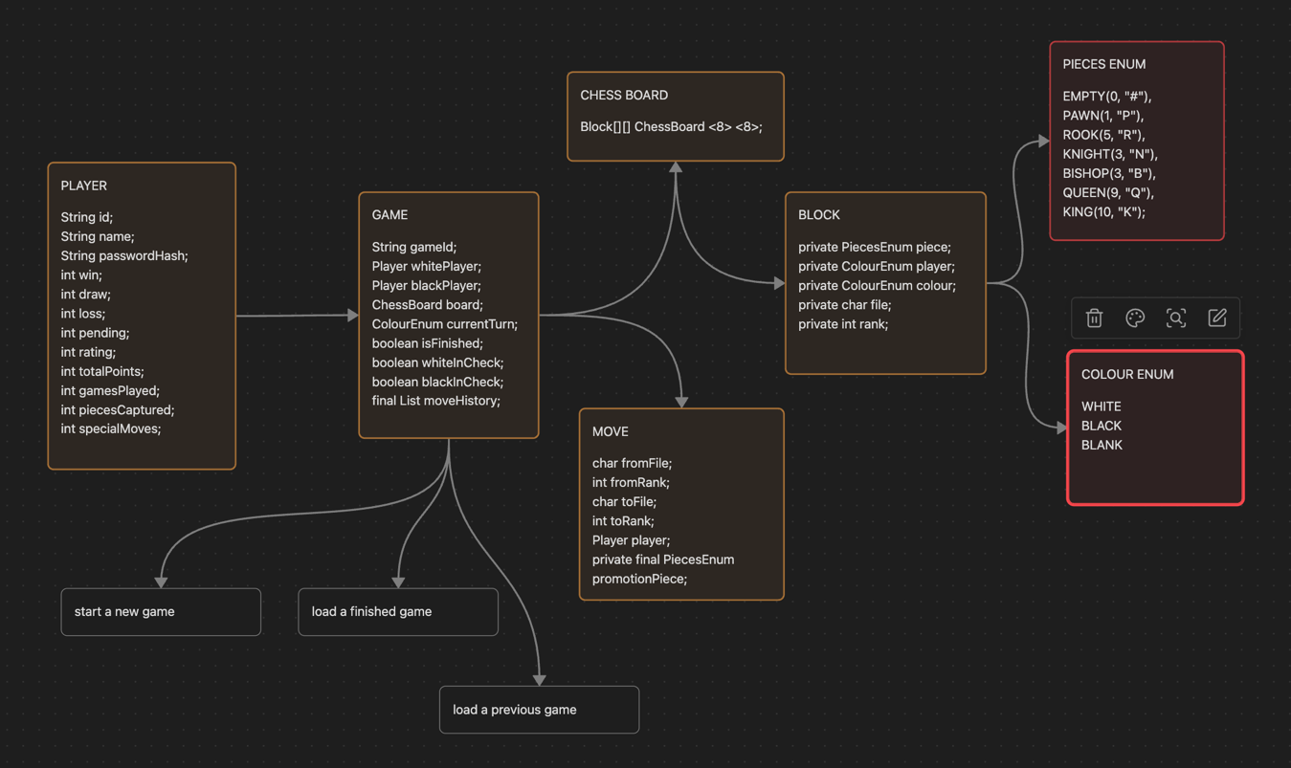

STORAGE
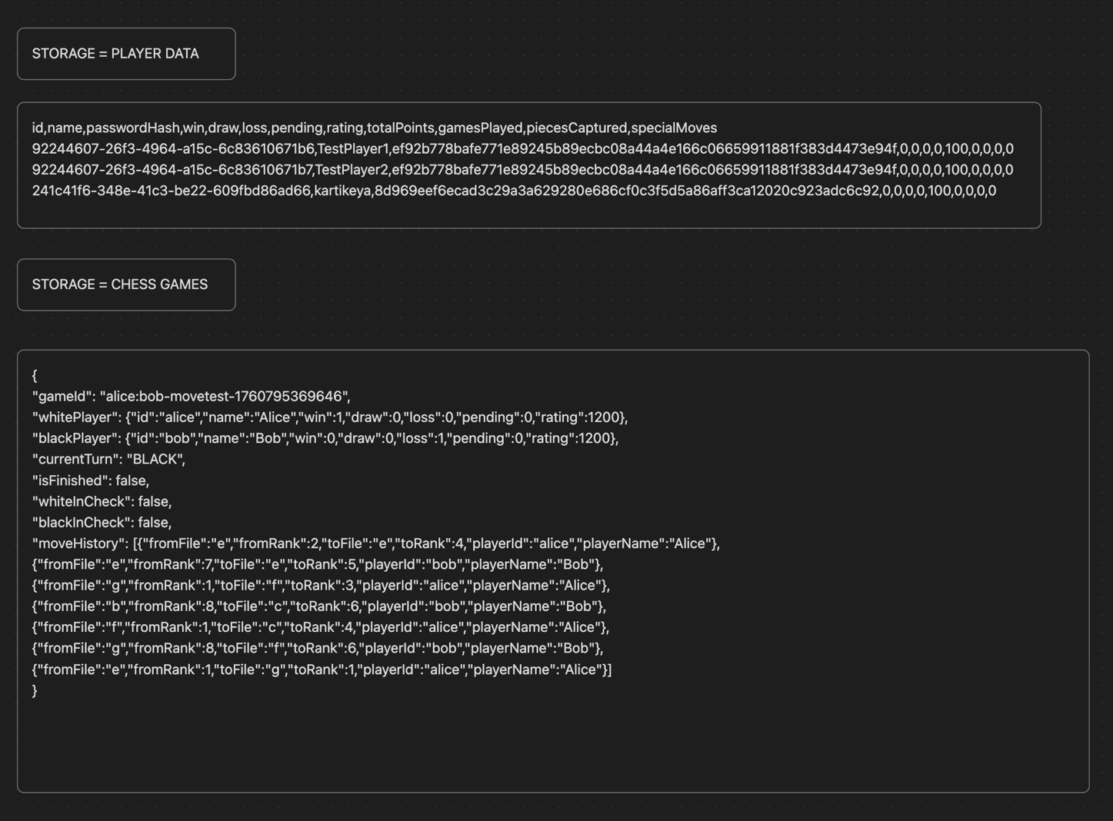
Required Features (Functional Requirements):

Initial Setup: Display the standard Chess board with pieces in their starting positions.
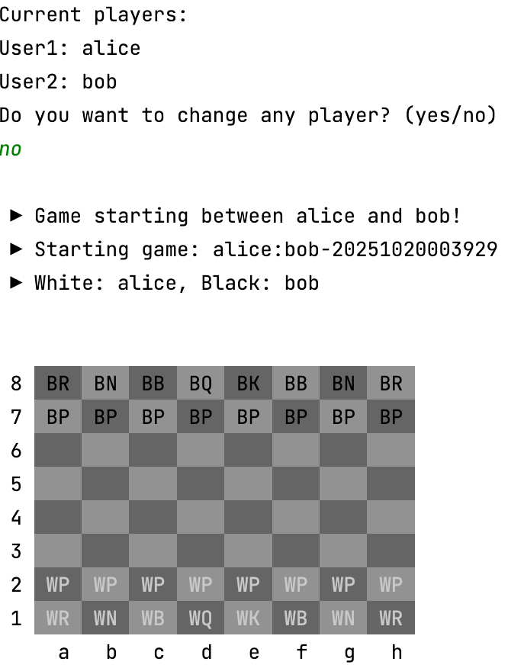
Player Setup: chess board initialization with player name and password.

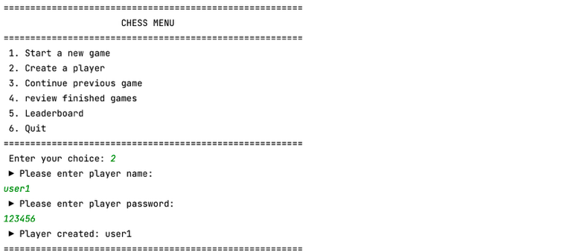

Board Display: Board is displayed with proper annotation
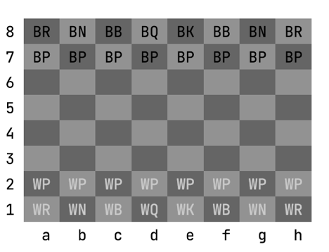
User Input: It is properly working
- Is it the player's turn? (working)
- Is there a piece of their color on the starting square? (working)
- Is the move pattern valid for the specific piece type? (working)
- Does the move capture an opponent's piece if moving to an occupied square? (working)
- Does the move leave their own King in check? (A move that results in the (working)
- player's own king being attacked is illegal) (working)
Piece Movement & Capture: Update the board state to reflect valid moves, including
removing captured pieces.
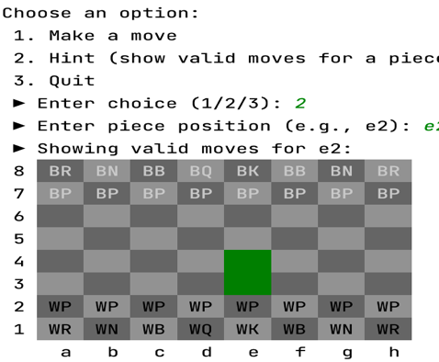
Game State: Keep track of the current player, the board configuration, and potentially
{
"gameId": "alice:bob-1760794254085",
"whitePlayer": {
"id": "alice",
"name": "Alice",
"win": 0,
"draw": 0,
"loss": 0,
"pending": 0,
"rating": 1200
},
"blackPlayer": {
"id": "bob",
"name": "Bob",
"win": 0,
"draw": 0,
"loss": 0,
"pending": 0,
"rating": 1200
},
"currentTurn": "WHITE",
"isFinished": true,
"whiteInCheck": false,
"blackInCheck": false,
"moveHistory": [
{
"fromFile": "e",
"fromRank": 2,
"toFile": "e",
"toRank": 4,
"playerId": "alice",
"playerName": "Alice"
},
{
"fromFile": "e",
"fromRank": 7,
"toFile": "e",
"toRank": 5,
"playerId": "bob",
"playerName": "Bob"
},
{
"fromFile": "g",
"fromRank": 1,
"toFile": "f",
"toRank": 3,
"playerId": "alice",
"playerName": "Alice"
},
{
"fromFile": "b",
"fromRank": 8,
"toFile": "c",
"toRank": 6,
"playerId": "bob",
"playerName": "Bob"
}
]
}

• Check Detection: Detect when a player's King is under attack (in check).
when king is under check no other piece can move until it is stopping the check. It is working
• Win Condition: The game ends when a player successfully captures the opponent's
King (a simplified win condition compared to formal checkmate). Announce the
winner.
when king is in check and nowhere to move game is marked isFinished = true
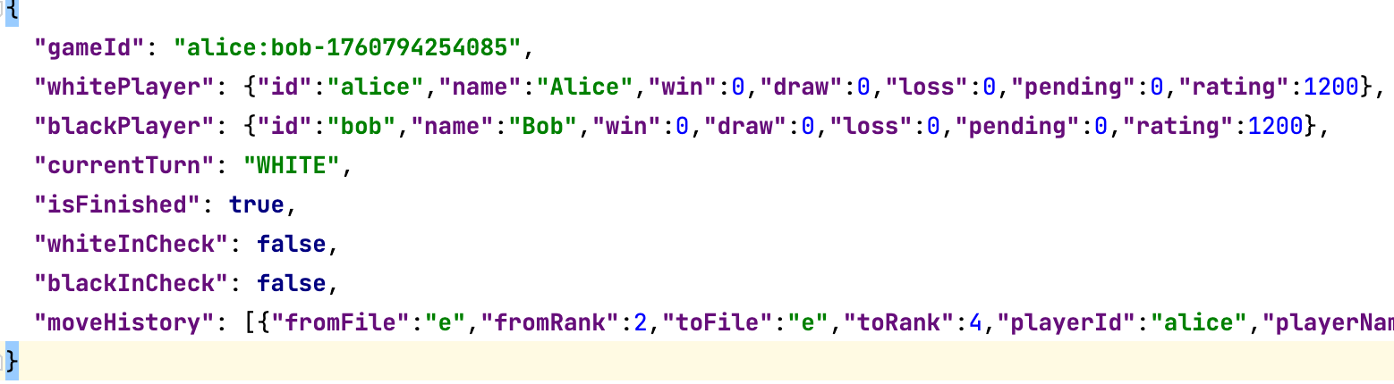
• Quit Command: Implement a command (e.g., 'quit' or 'q') to exit the program.
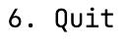
• Error Handling: Display appropriate error messages for invalid commands or illegal
moves and prompt the user for a new command.
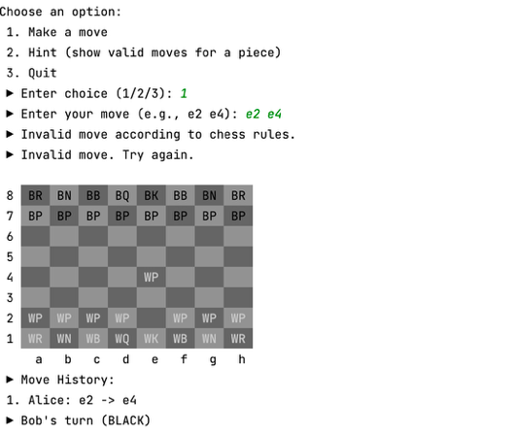
Smart Features
1. King is in check
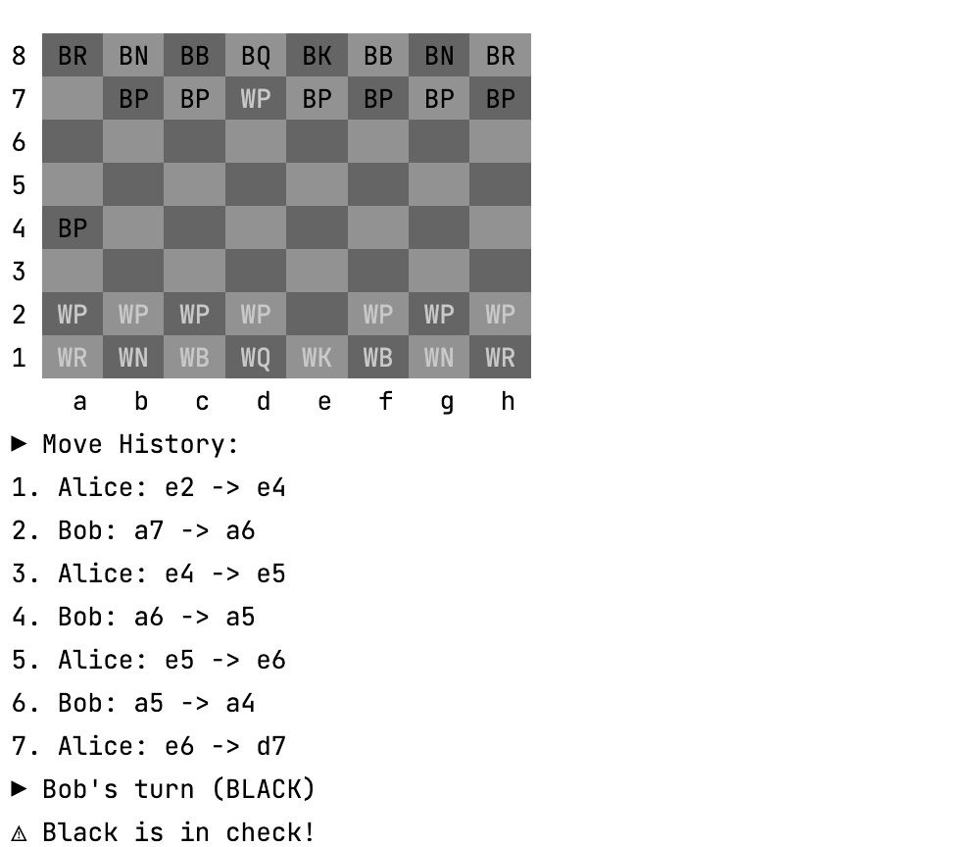
2. En passant
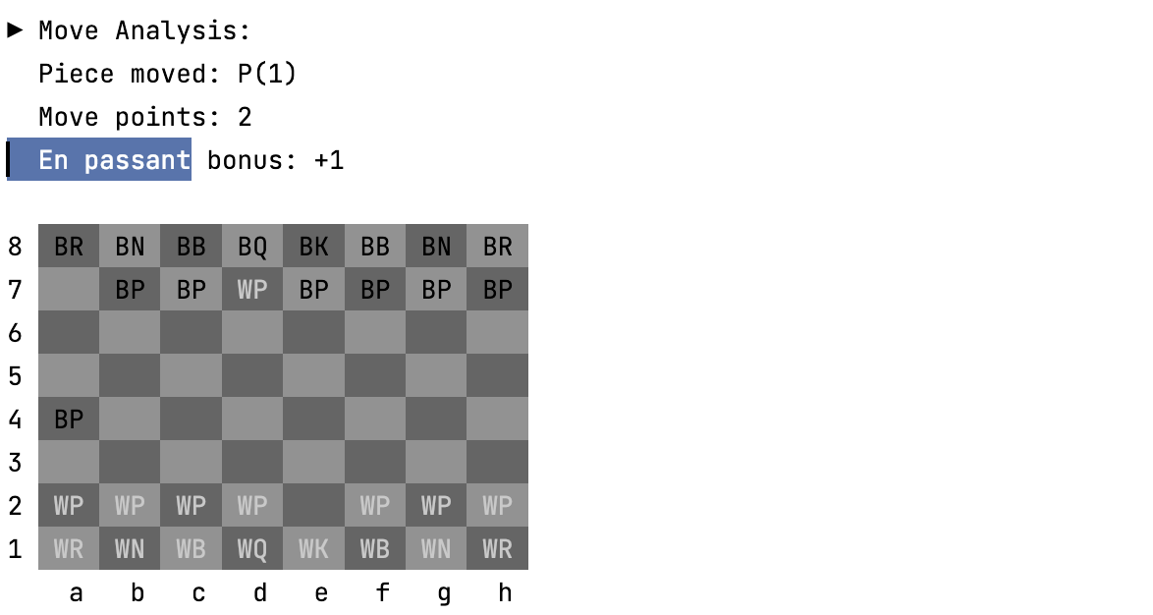
3. Pawn Promotion
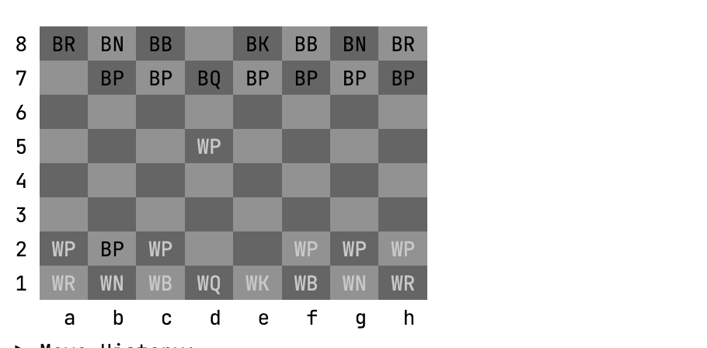
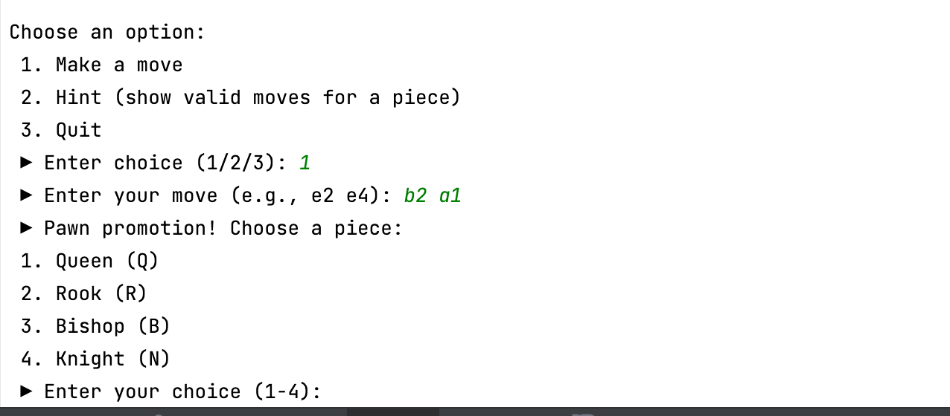

Extra Features

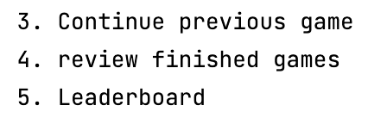

review finished games
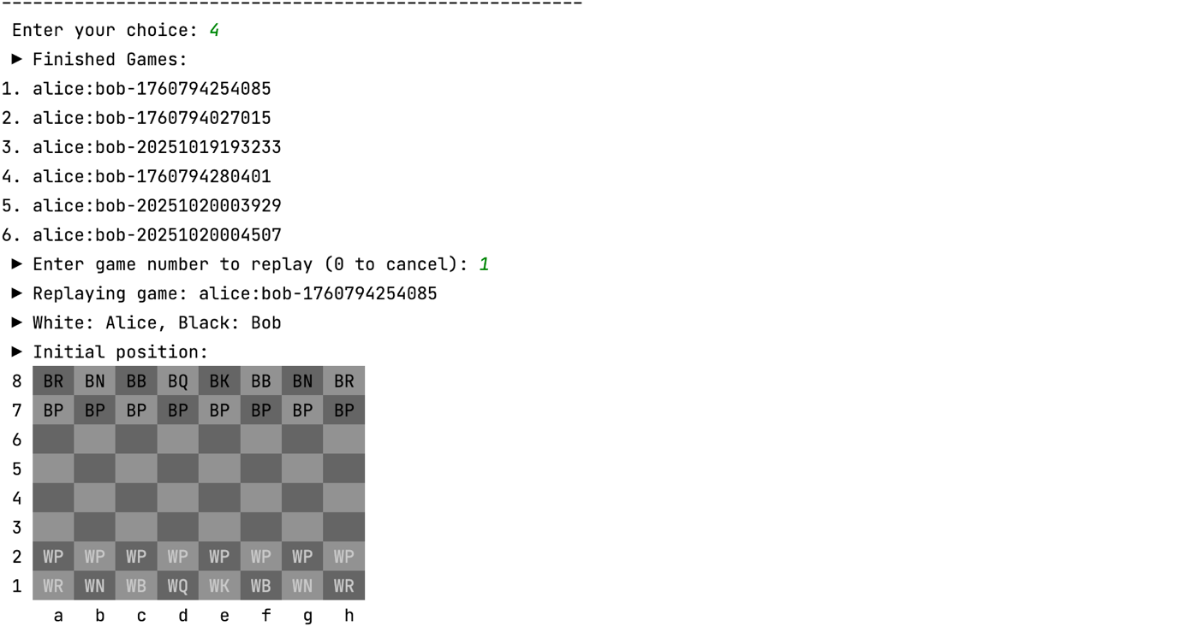

continuos previous game
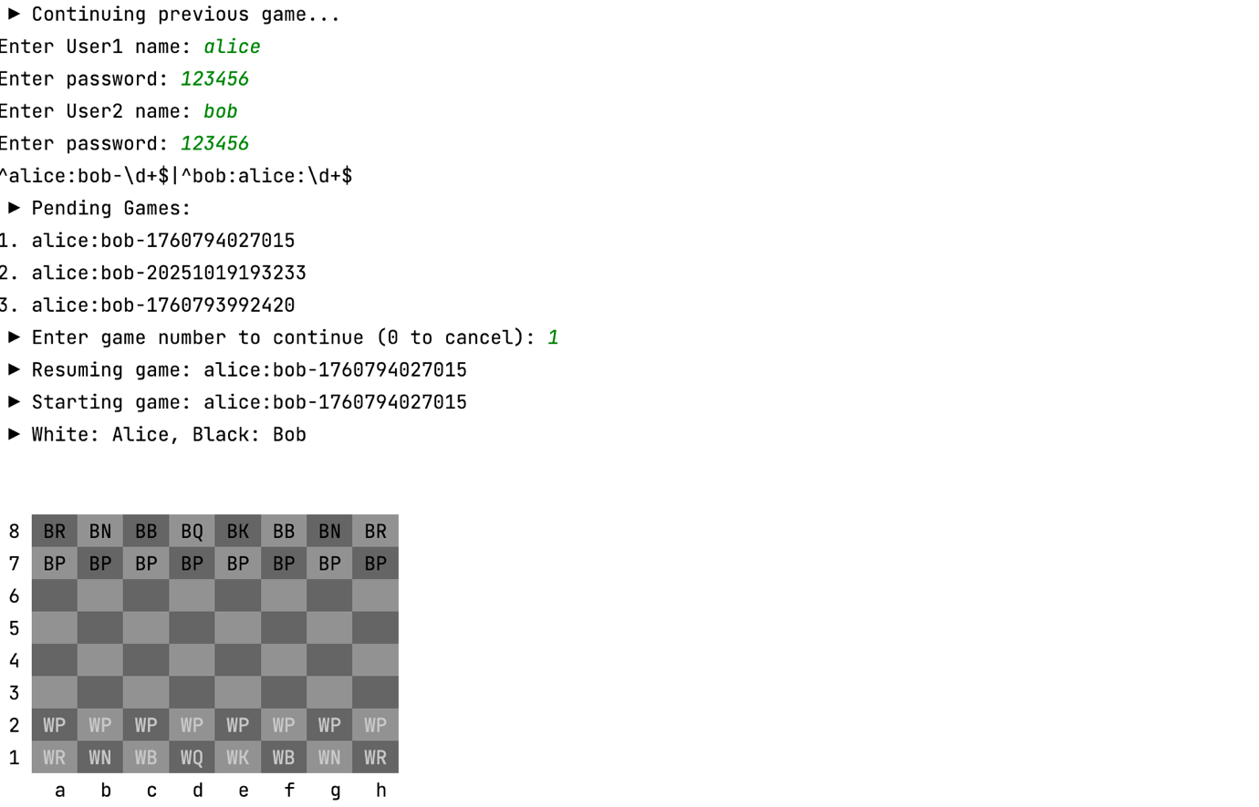
leaderboard
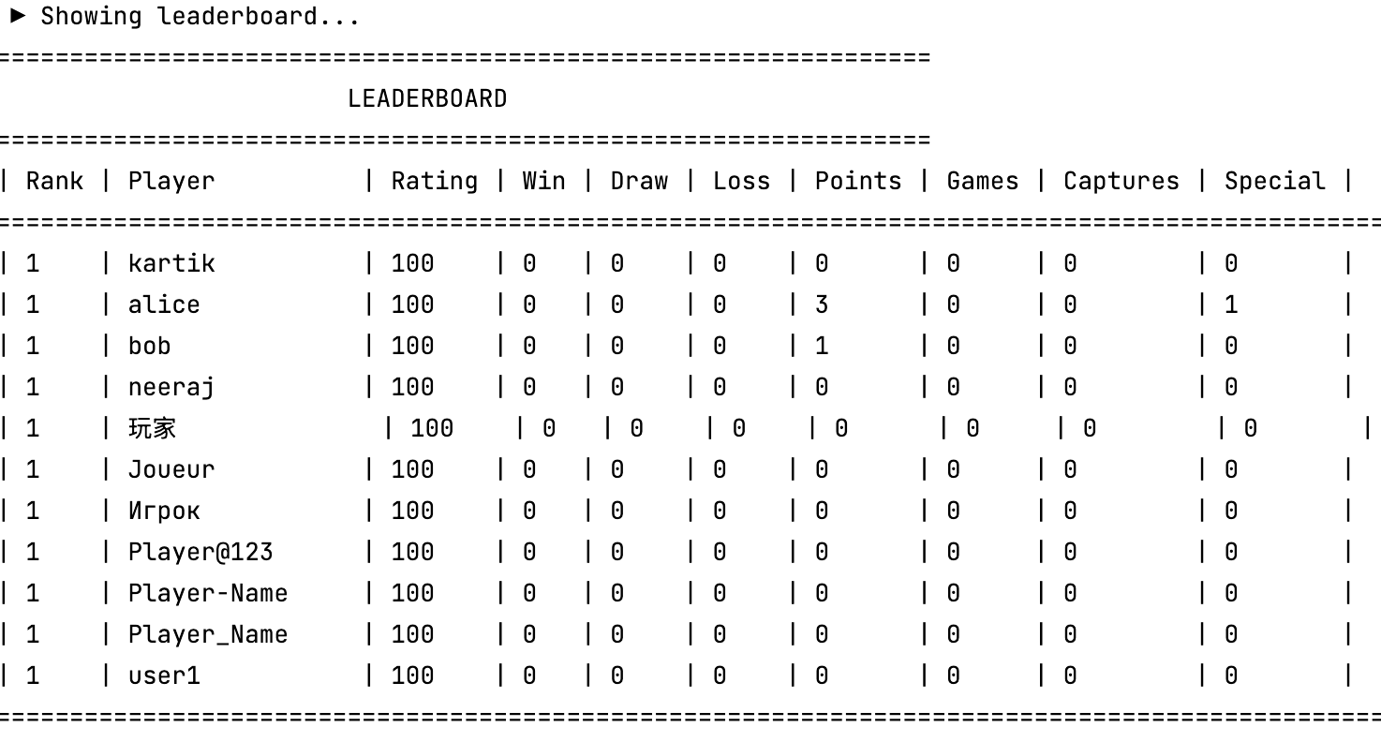

Testing Strategy
